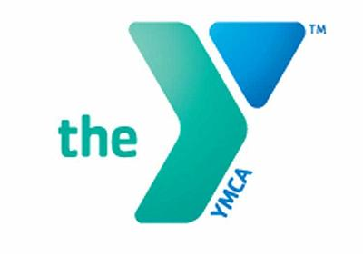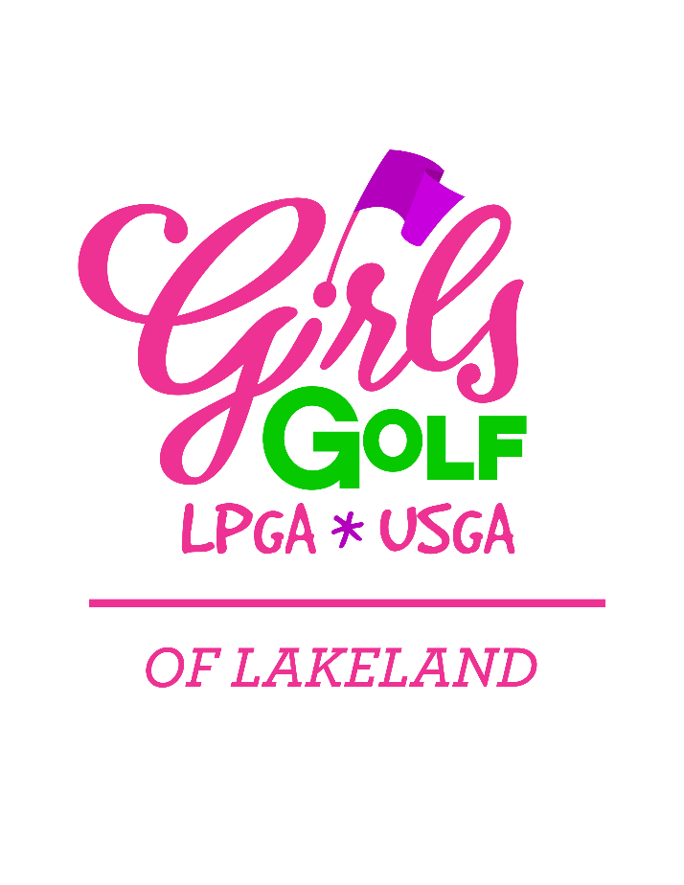

2019 Program Details

**Session & Classes Options**   
Girls Golf Class: Thursdays, 4:00-5:00pm  
(ages 6 & older)  
  
Advanced eLeader Class:   
Thursdays, 5:00-6:30pm   
(ages 11 & older, with Director discretion)

Costper 7 week session*  
Girls Golf Class: $40 YMCAWCF members/ $65 non-members   
  
Advanced eLeader Class: $50 YMCAWCF members/ $75 non-members

*\*Financial assistance is available for these programs; please see Suzanne.*ALL PARTICIPANTS MUST Register for the *FREE* LPGA-USGA on-line membership at: [www.GirlsGolf.org](http://www.GirlsGolf.org) (Lakeland, FL site)  
includes a membership kit from the LPGA.

Session Dates  
#1: January 17-February 28

#2: March 14-May 2   
(No class 3/28)

#3: August 22-October 3

#4: October 10-November 21  
(End of Season Party- November 22)

Summer Camps   
June 2019   
Dates & Times, TBD

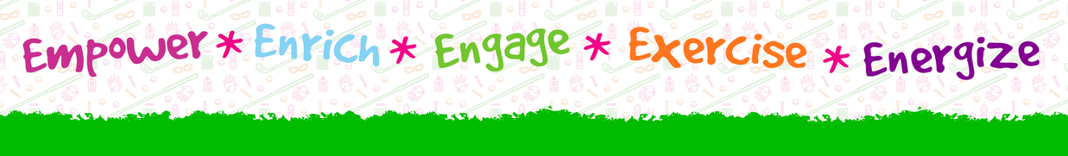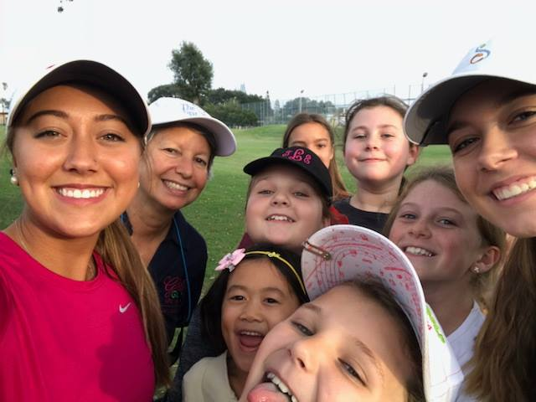

YMCA PAR 3, Homeof the first tee

1740 George Jenkins Boulevard, Lakeland, FL 33815, P 863-577-0236 www.ymcawcf.org

The LPGA-USGA Girls Golf classes are a program of the YMCA Par 3. They provide an opportunity for females ages 6-17 to learn to play golf, build lasting friendships, and experience competition in a fun, supportive environment preparing them for a lifetime of enjoyment with the game.